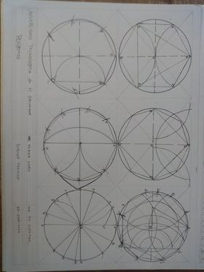

Dueñas Molina krissia magali 2520622020